Data Driven Fault Detection in Air Handling Unit

Faaiz Umar
Wasil Nadeem



DEPARTMENT OF COMPUTER SCIENCES
COMSATS UNIVERSITY ISLAMABAD, WAH CAMPUS
WAH CANTT – PAKISTAN
SESSION 2020-2024

Data Driven Fault Detection In Air Handling Unit
Undertaken By:

Faaiz Umar
REG. NO. CIIT/SP20-BCS-026/WAH
Sohaib Ahmed
REG. NO. CIIT/SP20-BCS-037/WAH

Supervised By:

Mrs. Samra Siddiqui

A DISSERTATION SUBMITTED AS A PARTIAL FULFILLMENT OF THE REQUIREMENTS FOR THE DEGREE OF COMPUTER SCIENCES

DEPARTMENT OF COMPUTER SCIENCES
COMSATS UNIVESITY ISLAMABAD, WAH CAMPUS
WAH CANTT – PAKISTAN
SESSION 2020-2024

FINAL APPROVAL

Certified that the project report titled “Data Driven Fault Detection In Air Handling Unit”, completed by Faaiz Umar (SP20-BCS-026) & Wasil Nadeem(SP20-BCS-037) is of sufficient standard, in our judgement to warrant its acceptance by COMSATS university Islamabad, WAH Campus for the award of Degree of Bachelor of Science in Computer Sciences.

- External Examiner Name

Professor

- Supervisor

Samra Siddiqui
Lecturer CUI WAH, Campus

- Head of Department

DR. SHERAZ ANJUM HOD / ASSOCIATE PROFESSOR
CUI WAH, Campus

DEDICATION

We dedicate this project to Allah Almighty, Our Creator. He has been the source of our strength throughout this project. We dedicate this project to our Parents, Teachers, and Colleagues who have been a source of inspiration for us and provide their moral, spiritual support.
We thank our parents for their blessings and the constant support that they have been for us and acted as a backbone and a major reason behind our accomplishment. All our gratitude goes to our Parents and Teachers who helped us in our journey and always supported us and kept pushing us to take new challenges to make this project better.
A special thanks to our outstanding supervisor Mrs. SAMRA SIDDIQUI who instilled in us the importance of working hard and not compromising on small matters.

ACKNOWLEDGEMENT

All the deepest sense of gratitude to Almighty ALLAH, the most compassionate and merciful who is omnipotent and omnipresent, and has divulged his knowledge to man, without his help and blessings, we wouldn’t have completed this project.
We thank Allah Almighty that we were able to accomplish this research successfully. We would like to pay our special regards to our Parents, for their valuable efforts, constructive criticism to make this project better and encouragement that we are able to see the culmination of our studies.
Our special gratitude is towards our supervisor Mrs. Samra Siddiqui, without her efforts and help we were unable to do such an amazing project. Working with her was a nice experience for us. We’ve learned a lot from her.
We would like to thank our esteemed CUI Wah Faculty and everyone at CUI Wah for making our four years at CUI Wah memorable.

PROJECT BRIEF

PROJECT NAME Data Driven Fault Detection in Air Handling Unit
ORGANIZATION NAME COMSATS UNIVERSITY ISLAMABAD,
WAH CAMPUS
OBJECTIVE THE PROJECT AIMS TO IMPLEMENT MACHINE LEARNING ALGORITHMS FOR PROACTIVE FAULT DETECTION IN AIR HANDLING UNIT.THE FOCUS IS ON IMPROVING SYSTEM RELAIBILTY AND PERFORMANCE BY ANALYZING REAL TIME DATA.
UNDERTAKEN BY FAAIZ UMAR (SP20-BCS-026)
WASIL NADEEM (SP20-BCS-037)
SUPERVISED BY SAMRA SIDDIQUI LECTURER
DEPARTMENT OF COMPUTER SCIENCE CUI, WAH CAMPUS
STARTED ON APRIL 2023
COMPLETED ON DECEMBER 2023
COMPUTER USED HP AMD RYZEN 5 5500U WITH RADEON
GRAPHICS 2.10 GHz, 16 GB RAM
SOURCE LANGUAGE PYTHON, HTML, CSS, DJANGO
OPERATING SYSTEM WINDOWS 10
TOOLS USED VS CODE, PYCHARM, SQLITE

ABSTRACT
The "Data-Driven Fault Detection in Air Handling Units" project represents a comprehensive exploration into the realm of HVAC system optimization. Employing cutting-edge machine learning methodologies, including deep neural networks, Support Vector Machines (SVM), and k-Nearest Neighbors (KNN), the system is designed to proactively identify and diagnose faults within air handling units. By analyzing real-time operational data, the project seeks to enhance the reliability and performance of these units. The integration of a user-friendly web interface provides stakeholders with intuitive data visualization tools, enabling effective monitoring and analysis. The project's overarching goal is to empower HVAC system operators with a proactive approach to maintenance, facilitating timely responses to potential faults and, ultimately, optimizing the overall efficiency and sustainability of air handling units. Through the synergy of advanced algorithms and accessible user interfaces, this project endeavors to set new standards for data-driven fault detection in HVAC systems.

TABLE OF CONTENTS

- INTRODUCTION 1
  - System Introduction 1
  - Background of the System 1
  - Objectives of the System 2
  - Significance of the System 2
- REQUIREMENT SPECIFICATIONS 3
  - Product Scope 3
  - Product Description 3
    - Product Perspective 3
    - Product Functionality 4
    - Users and Characteristics 4
    - Operating Environment 5
  - Specific Requirements 5
    - Functional Requirements 5
      - Data collection and Integration 5
      - Machine Learning Algorithms 5
      - Historical Data Storage 5
      - Fault Classification and Severity 6
      - Integration With Maintenance 6
      - Interactive Dashboard 6
      - Trend Analysis Chart 6
    - Behavioral Requirements 6
      - Login 7
      - Real Time Fault Detection 8
      - Predictive Maintenance 9
      - Web Interface 9
    - External Interface Requirements 10
      - User Interface 10
      - Home P 26
      - Software Interface 26
      - Communication Interface 27
  - Non-functional Requirements 27
    - Performance Requirements 27
    - Safety and Security Requirements 27
    - Software Quality Attributes 27
      - Availability 27
      - Reliability 27
      - Maintainability 28
      - Portability 28
      - Extensibility 28
      - Reusability 28
- DESIGN SPECIFICATIONS 29
  - Introduction 29
  - Composite Viewpoint 29
  - Logical Viewpoint 29
  - Information Viewpoint 30
  - Interaction Viewpoint 34
  - State Dynamics Viewpoint 37
  - Algorithmic Viewpoint 39
- DEVELOPMENT AND TOOLS 40
  - Introduction 40
  - Development Plan 40
  - Development Tools 41
  - Conclusion and Future Work/Extensions 41
- QUALITY ASSURANCE 42
  - Introduction 42
  - Traceability Matrix 42
  - Test Plan 43
- USER MANUAL 59
  - Introduction 59
  - Hardware/Software Requirements for the System 59
  - Installation guide for Application 59
  - Operating Manual 63
    - First Screen 63
    - Second Screen 63

- Conclusion 53

8 References…………………………………………………………………………………………….60
LIST OF FIGURES
Figure 2.1: System Overview 4
Figure 2.2: Use Case Diagram for System 7
Figure 2.3: Login 10
Figure 2.4: Wrong login…………………………………………………………………………….10
Figure 2.5: Home Page 11
Figure 2.6: No fault detection page………………………………………………………………….11
Figure 3.1: Deployment Diagram 29
Figure 3.2: Class Diagram 30
Figure 3.6: Sequence diagram for Login 34
Figure 3.7: Sequence diagram for Real Time Fault Detection 34
Figure 3.8: Sequence for predictive maintenance 35
Figure 3.9: Sequence Diagram for Admin Login 35
Figure 3.10: State Diagram 37
Figure 3.16.1: Algorithmic Viewpoint for Neural Network 39
Figure 3.16.2: Algorithmic Viewpoint for Neural Network 40
Figure 3.17.1: Algorithmic Viewpoint for KNN 42
Figure 3.17.2: Algorithmic Viewpoint for KNN 42
Figure 3.18: Algorithmic viewpoint for SVM 43
Figure 5.1: Ai SVM test case………………………………………………………………………...48
Figure 5.2: Ai KNN test case…………………………………………………………………………49
Figure 5.3 Ai NN test case……………………………………………………………………………50
Figure 6.4.1.1 First screen…………………………………………………………………………….56
Figure 6.4.1.2 Invalid login……………………………………………………………………………57
Figure 6.4.2.1 Second screen with fault detection…………………………………………………….56
Figure 6.4.2.2 Second Screen with no fault detected…………………………………………………..57

LIST OF TABLES
Table 2.1: Login 7
Table 2.2: Real Time Fault Detection 8
Table 2.3: Predictive Maintenance 8
Table 2.4: Web Interface 9
Table 3.5.1: State Transition Matrix 9
Table 4.2: Development Plan 43
Table 5.1: Traceability Matrix 46

INTRODUCTION

System Introduction

Our project on data-driven fault detection in air handling units (AHUs) represents a groundbreaking approach to HVAC system maintenance. Leveraging advanced data analytics and machine learning, our system aims to proactively identify and diagnose faults within AHUs by analyzing operational data in real-time. The web-based platform serves as a central hub for visualizing and interpreting the results of fault detection algorithms. The user-friendly interface provides stakeholders with a comprehensive view of the AHU performance, highlighting potential issues and offering actionable insights for preventive maintenance. The system's sophistication lies in its ability to seamlessly integrate with AHU sensors and data sources, continuously monitoring key parameters to ensure optimal functionality. The web page dedicated to visualization not only displays real-time data but also offers historical trends and performance analytics, empowering users to make informed decisions for efficient HVAC system management. Through this project, we aim to redefine the landscape of fault detection in AHUs, ushering in a new era of data-driven precision and reliability in HVAC maintenance.

Background of the System
Data-driven fault detection in air handling units (AHUs) is a critical advancement in HVAC system management, addressing the need for proactive maintenance and optimal performance. Traditional fault detection methods often rely on reactive approaches, leading to increased downtime and higher maintenance costs. In contrast, our project leverages advanced data analytics and machine learning algorithms to analyze operational data from AHUs, aiming to identify potential faults before they escalate. By monitoring various parameters such as airflow, temperature, and pressure, the system can detect deviations from expected norms and provide insights into potential issues, enabling timely intervention and minimizing disruptions. The integration of real-time sensor data and historical performance metrics ensures a comprehensive understanding of AHU behavior, allowing for more accurate fault predictions. The web-based visualization platform serves as a user-friendly interface for stakeholders to interact with and interpret the data. Through this platform, users can access intuitive visualizations, trend analyses, and fault notifications, empowering them to make informed decisions regarding maintenance and system optimization. The web page's design prioritizes usability, ensuring that even non-experts can navigate and benefit from the insights provided by the data-driven fault detection system.

Objectives of the System

- Develop algorithms for real-time fault detection in Air Handling Units (AHUs) based on operational data analysis.
- Implement predictive maintenance strategies using data analytics to forecast and schedule maintenance activities, minimizing downtime.
- Design a data collection framework integrating sensor data, historical records, and external factors for a comprehensive view of AHU operation.
- Utilize machine learning techniques for continuous learning and improvement of fault detection accuracy.
- Create a user-friendly web interface for system administrators and maintenance personnel to interact with real-time visualizations of AHU operational status.

Significance of the System

The significance of our data-driven fault detection system in air handling units (AHUs) lies in its potential to revolutionize HVAC maintenance practices. By leveraging advanced analytics and machine learning, the system proactively identifies and diagnoses faults in AHUs based on operational data, enabling predictive maintenance and minimizing downtime. This not only enhances system reliability but also contributes to energy efficiency and cost savings. The web-based visualization component of our project adds another layer of value by providing an intuitive platform for stakeholders to interact with and interpret the data-driven insights. This web page serves as a user-friendly interface, offering real-time visualizations of AHU performance metrics, fault alerts, and predictive analytics. This not only empowers maintenance teams with actionable information but also facilitates informed decision-making for optimizing system efficiency and overall building performance.

REQUIREMENT SPECIFICATIONS

Product Scope
The product scope of our Data-Driven Fault Detection in Air Handling Unit (AHU) system encompasses a comprehensive solution for real-time monitoring and predictive maintenance of HVAC systems. The system will leverage advanced data analytics and machine learning algorithms to continuously analyze operational data from AHUs, proactively detecting potential faults and performance anomalies. Users will have access to a user-friendly web application where dynamic visualizations and insights into the AHU's operational health will be displayed. The web page will serve as an intuitive dashboard, providing a graphical representation of system parameters, alert notifications, and historical performance trends. This visualization platform aims to empower users, from maintenance personnel to facility managers, with actionable insights, enabling them to make informed decisions and optimize the performance of AHUs efficiently. The user interface will be designed for ease of use, ensuring accessibility and enhancing the overall user experience in monitoring and managing AHU health.

Product Description

Product Perspective

Our data-driven fault detection system for air handling units (AHU) is a cutting-edge solution designed to elevate HVAC maintenance and performance. Leveraging advanced analytics and machine learning algorithms, the system analyzes real-time operational data to proactively identify and diagnose faults within AHUs. The product provides a user-friendly web interface, serving as a centralized platform for visualization and analysis of the fault detection insights. The web page offers an intuitive and interactive dashboard, allowing users to monitor the health and performance of AHUs in real-time. Through comprehensive visualizations, users can easily interpret complex data patterns, enabling swift decision-making for preventive maintenance and minimizing downtime. The platform not only enhances the efficiency of fault detection but also empowers users with actionable insights to optimize the overall performance and longevity of air handling units.
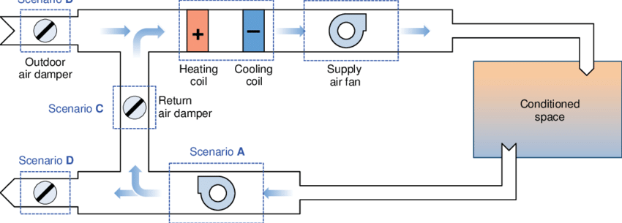
Figure 2.1: System Overview

Product Functionality
Following are the functionality of our system.

- Real-time Monitoring
- Advanced Analytics
- Fault Detection
- Visualization Dashboard
- Interactive Exploration
- Alerts & Notifications
- Historical Analysis

Users and Characteristics
User characteristics:
The Data-Driven Fault Detection in Air Handling Unit (AHU) system is designed to cater to a diverse user base, including HVAC technicians, facility managers, and system operators. These users benefit from real-time insights into the performance of AHUs, enabling proactive maintenance and minimizing downtime. The system's characteristics include sophisticated machine learning algorithms that analyze operational data to detect anomalies and potential faults within AHUs. It offers a user-friendly interface with intuitive visualizations, allowing users to interpret complex data effortlessly. Key characteristics also encompass the system's adaptability to various AHU configurations and its scalability to accommodate different-sized HVAC systems. The web page for data visualization is crafted to be interactive and informative, presenting a comprehensive overview of AHU health, system efficiency, and potential faults. Through this platform, users can access detailed analytics, historical data, and actionable insights, empowering them to make informed decisions and optimize the performance of their air handling units.

Operating Environment
Operating System: Windows
Hardware: Nil Server: Nil Database: SQlite
Languages: HTML, CSS, PYTHON, DJANGO,
Framework: Python based web framework
Development Environment: Visual Studio Code,

Specific Requirements

Functional Requirements
Following is the functional requirement of our system.

      - Data Collection & Integration

The system must integrate with sensors and data sources from AHUs to collect real-time operational data, ensuring a comprehensive and accurate dataset for fault detection.
      - Machine Learning Algorithms

Implement advanced machine learning algorithms for fault detection, capable of analyzing patterns and anomalies within the collected data to identify potential issues.
      - Historical Data Storage

The system should store historical data for analysis and trend identification, allowing users to review past performance and understand the evolution of faults over time.
      - Fault Classification & Severity

Provide a mechanism to classify detected faults based on type and severity, aiding users in prioritizing and addressing issues based on their impact on AHU performance.

      - Integration With Maintenance System

Enable integration with existing maintenance systems to streamline the workflow, allowing users to seamlessly transition from fault identification to the initiation of maintenance procedures.
      - Interactive Dashboard

Develop interactive dashboards that allow users to visualize real-time and historical data, providing a comprehensive overview of AHU performance.
      - Trend Analysis Charts

Implement trend analysis charts to showcase the historical performance of AHUs, aiding in the identification of recurring issues or patterns.

Behavioral Requirements
Behavioral requirement defines the behavior of the system between inputs and outputs. Usually, the Behavioral requirements are imposed by the customers/user who are going to use the system eventually.

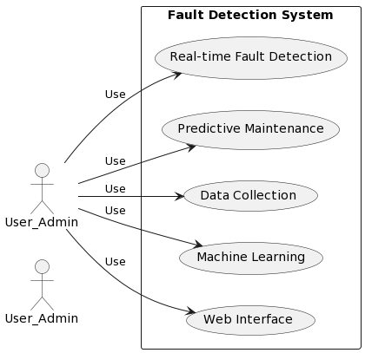
Figure 2.2: Use Case Diagram for System

      - Login

Use Case ID: | UC001
Use Case Name: | Login
Actors: | Primary: User_Admin Secondary: Not explicitly defined
Description: | The user/admin logs into the Fault Detection System.
Trigger: | The user/admin accesses the system login page.
Preconditions: | PRE-01. The system is operational, and the user/admin has valid credentials.
Postconditions: | POST-01. Upon successful login, the user/admin gains access to the system.
Normal Flow: | - The user/admin navigates to the system login page.  - Enters valid username and password.  - Submit the login form
Exceptions: | - If invalid credentials are entered, an error message is displayed.  - If the system is down, an error message is displayed.

Table 2.1 login
      - Real Time Fault Detection

Use Case ID: | UC002
Use Case Name: | Real Time Fault Detection
Actors: | Primary: User_Admin Secondary: Not explicitly defined
Description: | Develop algorithms for real-time fault detection in Air Handling Units (AHUs) based on operational data analysis
Trigger: | Regular monitoring of AHU operational data
Preconditions: | PRE-01. AHU sensors and data sources are operational
Postconditions: | POST-01. Detected faults are identified and logged for further analysis.
Normal Flow: | - The system continuously monitors operational data from AHUs.  - Algorithms analyze the data in real-time.  - Anomalies or faults are identified.  - Detected faults are recorded in the system for review.
Exceptions: | - If sensor data is inconsistent or unavailable, the system alerts administrators.  - If algorithmic analysis encounters errors, the system logs and reports the issue. |

Table 2.2 Real Time Fault Detection

      - Predictive Maintenance

Use Case ID: | UC003
Use Case Name: | Predictive Maintenance
Actors: | Primary: User_Admin Secondary: Not explicitly defined
Description: | Implement predictive maintenance strategies using data analytics to forecast and schedule maintenance activities, minimizing downtime
Trigger: | Scheduled maintenance intervals or detected faults.
Preconditions: | PRE-01. Historical data on AHU performance is available.
Postconditions: | POST-01. Maintenance schedules are optimized based on predictive analytics.
Normal Flow: | - The system utilizes historical data to predict potential faults.  - Predictive maintenance algorithms forecast optimal maintenance schedules.  - Maintenance tasks are scheduled and communicated to relevant personnel.  - Preventive measures are taken to minimize downtime
Exceptions: | - If historical data is insufficient, the system relies on default maintenance schedules.  - Unforeseen critical faults trigger immediate maintenance actions

Table2.3 Predictive Maintenance
      - Web Interface

Use Case ID: | UC004
Use Case Name: | Web Interface
Actors: | Primary: User_Admin Secondary: Not explicitly defined
Description: | Create a user-friendly web interface for system administrators and maintenance personnel to interact with real-time visualizations of AHU operational status.
Trigger: | Access to the Fault Detection System.
Preconditions: | PRE-01. Users have valid login credentials
Postconditions: | POST-01. Users can effectively monitor and manage AHU status through the web interface.
Normal Flow: | - Users log in to the web interface.  - The system authenticates user credentials.  - Users are presented with real-time visualizations of AHU operational status.  - Interactive features allow users to explore detailed data and initiate actions.
Exceptions: | - Invalid login attempts are met with appropriate error messages.  - If the web interface encounters technical issues, users are notified.

Table 2.4 Web Interface

External Interface Requirements
      - User Interface

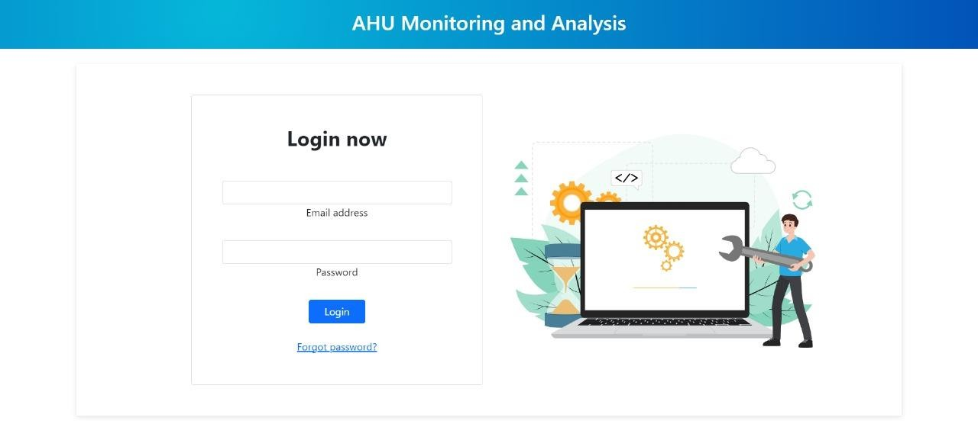
figure 2.3 login page

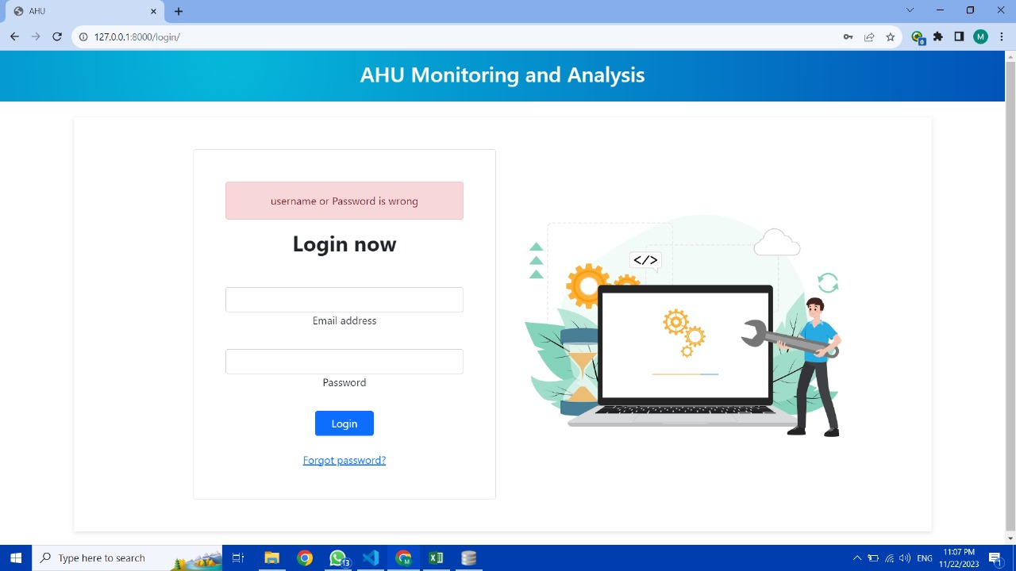
Fig 2.4 wrong login detected
.

      - Home Page
        - Home Page:
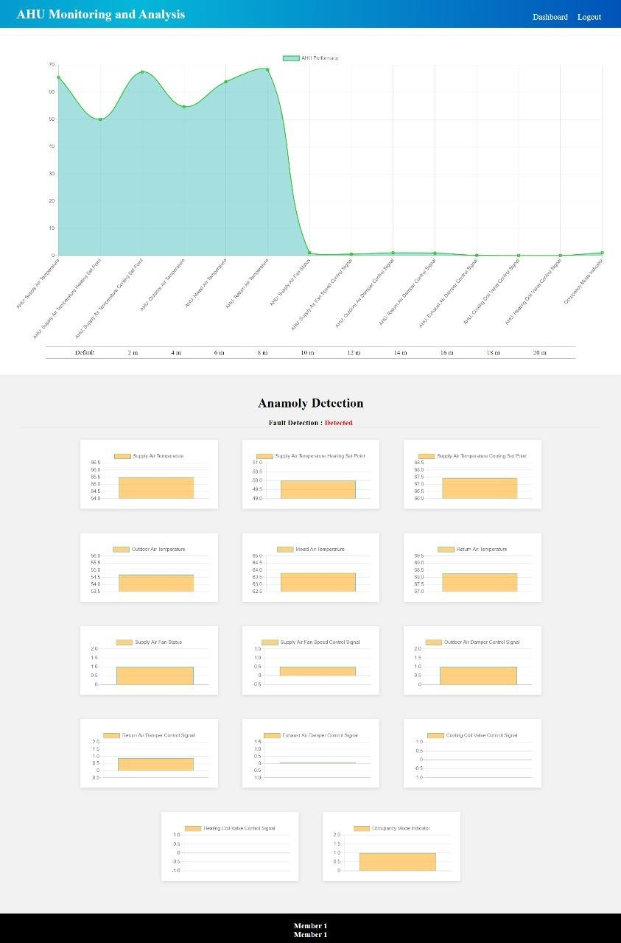
figure2.5homepage

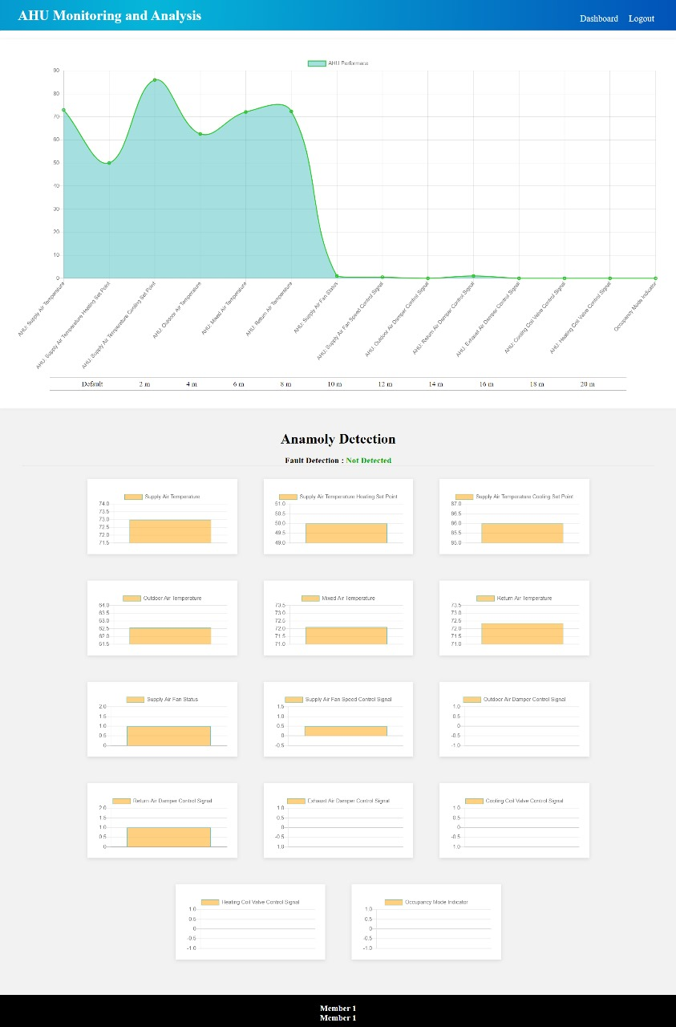
fig 2.6 no fault detection page
1

      - Hardware Interface
In our system no hardware is used because it is a AI - Web project. If we must define the hardware in our system, it is only the desktop and a keyboard to operate and to work on our website.
      - Software Interface
In our software
- Implement real-time graphs and charts to visualize crucial parameters, enabling users to monitor system performance at a glance. Use color-coded indicators for easy identification of normal and faulty conditions.

- Integrate a dedicated panel for fault identification, displaying detected anomalies, error codes, and fault categories. Provide a log or history of past faults for reference and analysis.

- Include diagnostic tools for in-depth analysis, allowing users to drill down into specific time frames and parameters associated with detected faults. Implement trend analysis graphs to identify patterns leading to faults.

- Ensure the web page is responsive, offering a seamless user experience across different devices and screen sizes. Optimize for both desktop and mobile viewing.

      - Communication Interface
User can communicate only when the internet is available. The system uses communication resources which include HTTP protocol for communication with web server.

Non-functional Requirements

Performance Requirements

The performance relies heavily on the internet connection used by the user, better the internet connection, the quicker he will get the results.

Safety and Security Requirements

Safety and security requirements for data-driven fault detection in air handling units include implementing robust encryption protocols to safeguard sensitive operational data and ensuring system resilience against cyber threats. The web page for visualization should prioritize user authentication mechanisms, restricting access to authorized personnel only, and incorporate secure coding practices to prevent vulnerabilities, thereby maintaining the integrity of the fault detection system.

Software Quality Attributes

      - Availability

The system ensures high availability, minimizing downtime for the Air Handling Unit (AHU) by implementing robust backup mechanisms and redundant components, ensuring continuous fault detection capabilities even in the face of potential disruptions.
      - Reliability

The software guarantees reliable fault detection by employing advanced algorithms and statistical models, providing accurate insights into AHU performance. It undergoes rigorous testing to ensure consistent and dependable results in diverse operational conditions.

      - Maintainability

The system is designed with a modular and easily maintainable architecture, allowing for swift updates and bug fixes. This ensures that the fault detection capabilities can adapt to evolving AHU technologies and emerging fault patterns efficiently.

      - Extensibility
The software prioritizes reusability by employing modular design principles. This allows individual components of the data-driven fault detection system for air handling units to be efficiently reused in different contexts, promoting scalability and reducing redundancy in development efforts.
      - Reusability

The architecture is designed for extensibility, enabling easy integration of new features, algorithms, and updates to adapt to evolving requirements in fault detection for air handling units. This flexibility ensures that the system can grow and incorporate advancements in data-driven methodologies without major overhauls.

DESIGN SPECIFICATIONS

Introduction
In this chapter we have shown different system views with the help of diagrams.

Composite Viewpoint

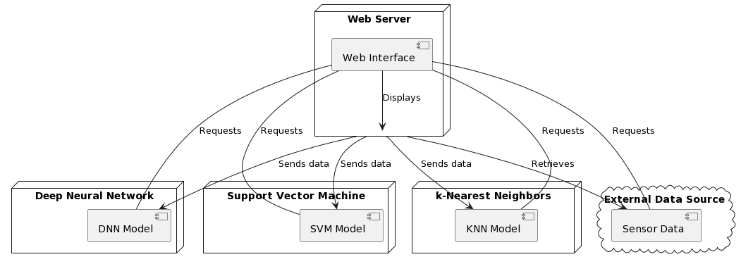
Figure 3.1: Deployment Diagram

Logical Viewpoint

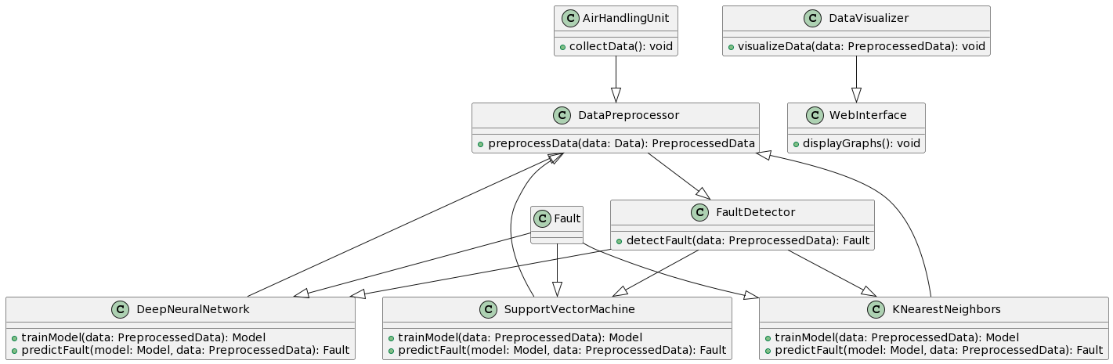

Figure 3.2: Class Diagram

Information Viewpoint

Entity-Relationship Diagram is not required for our project.

Interaction Viewpoint

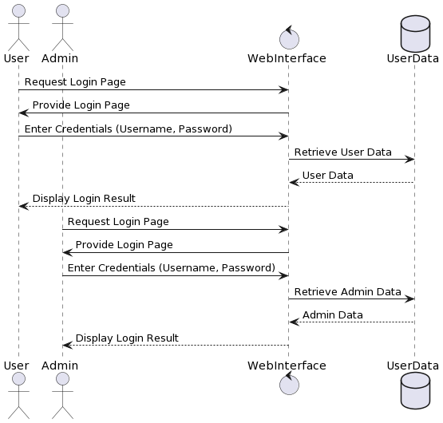
Figure 3.6: Sequence diagram for Login

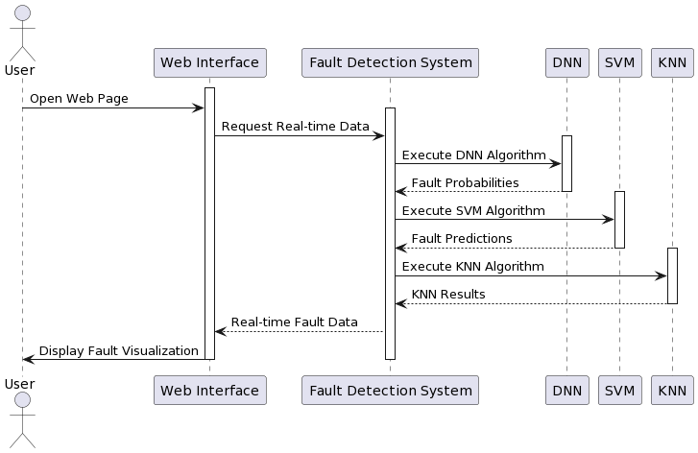
Figure 3.7: Sequence diagram for Real Time Fault Detection
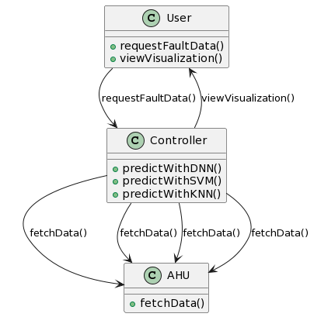
Figure 3.8: Sequence Diagram for Predictive Maintenance

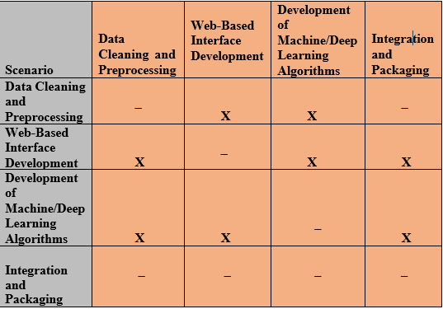
Table 3.5.1State Transition Matrix

State Dynamics Viewpoint

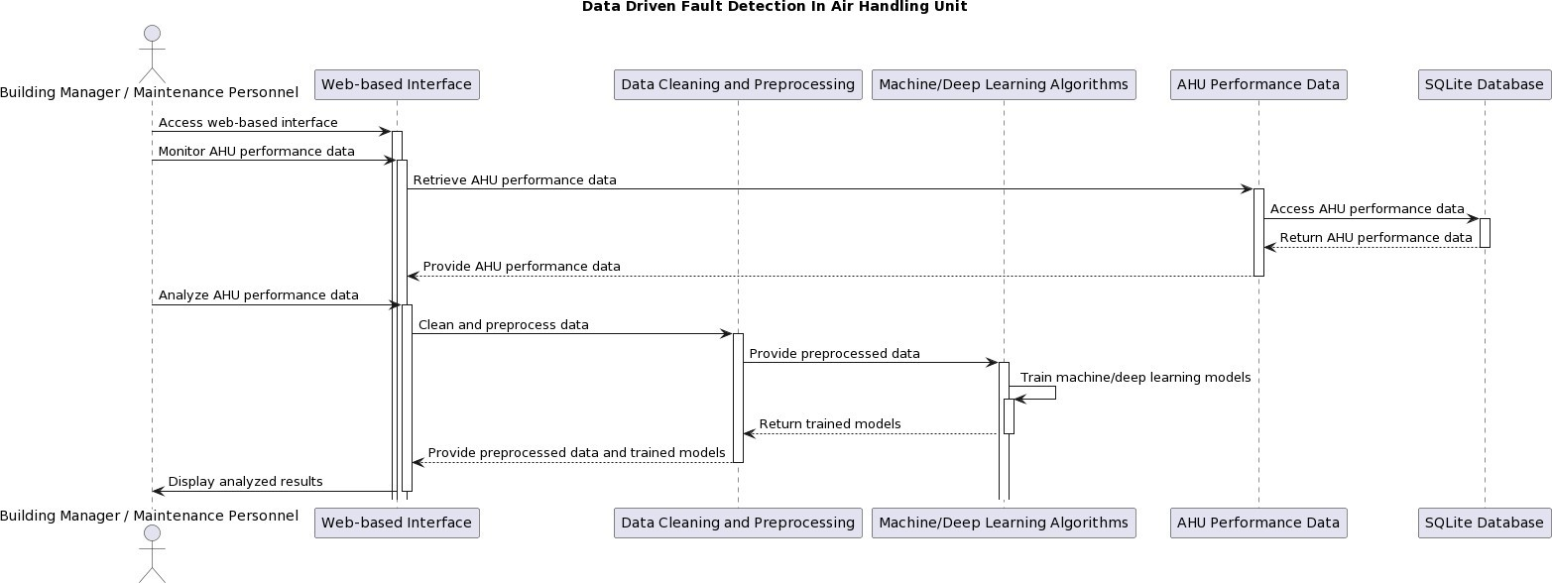
Fig 3.10 state diagram

Algorithmic Viewpoint
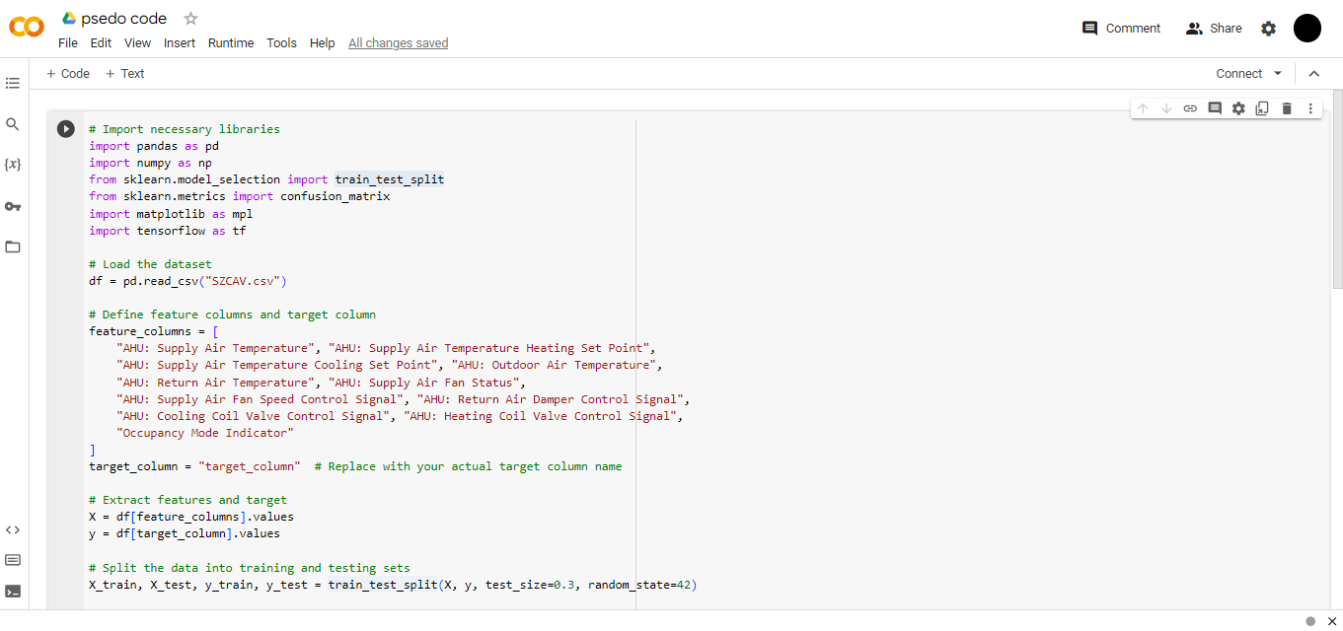
Figure 3.16.1: Algorithmic Viewpoint for Neural Networks
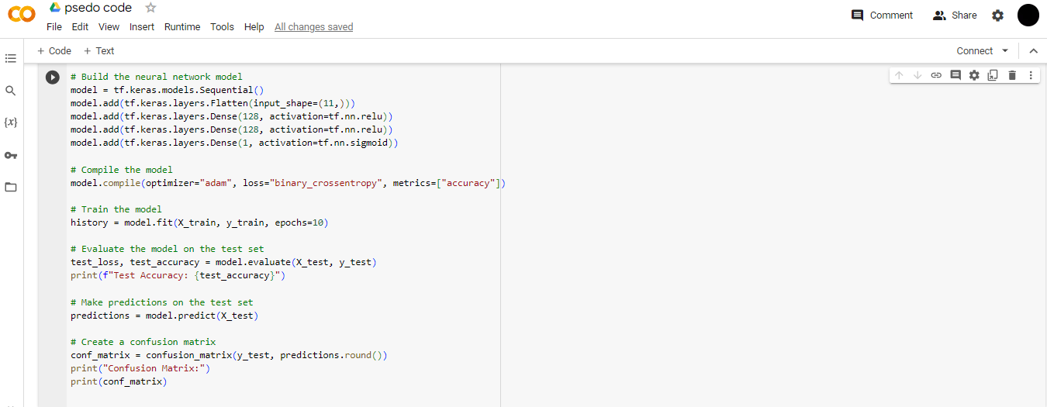
Figure 3.16.2 Algorithmic Viewpoint For Neural Network

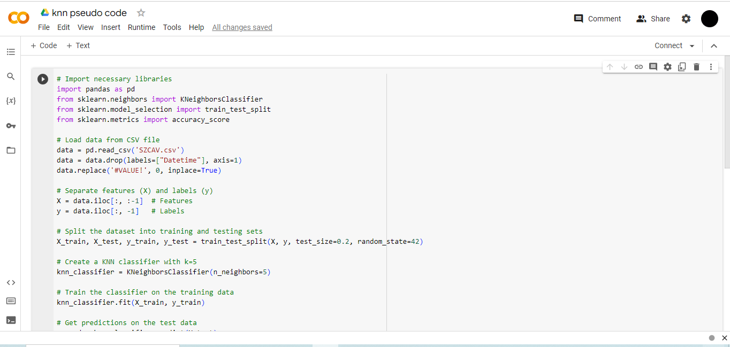

Figure 3.17.1: Algorithmic Viewpoint for KNN
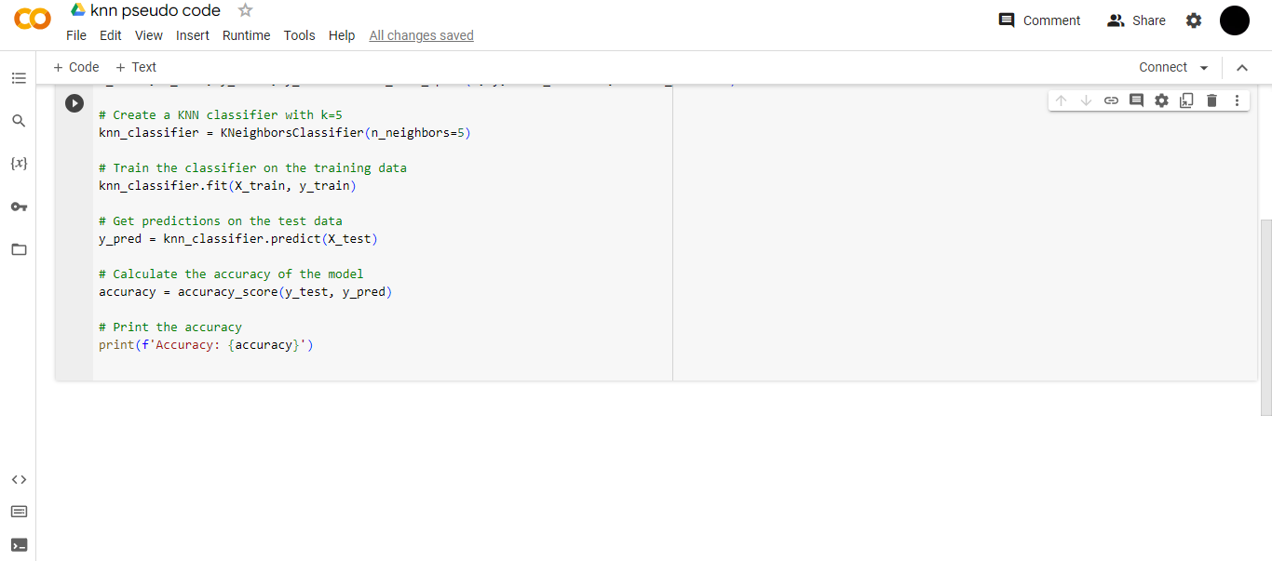

Figure 3.17.2: Algorithmic Viewpoint for KNN
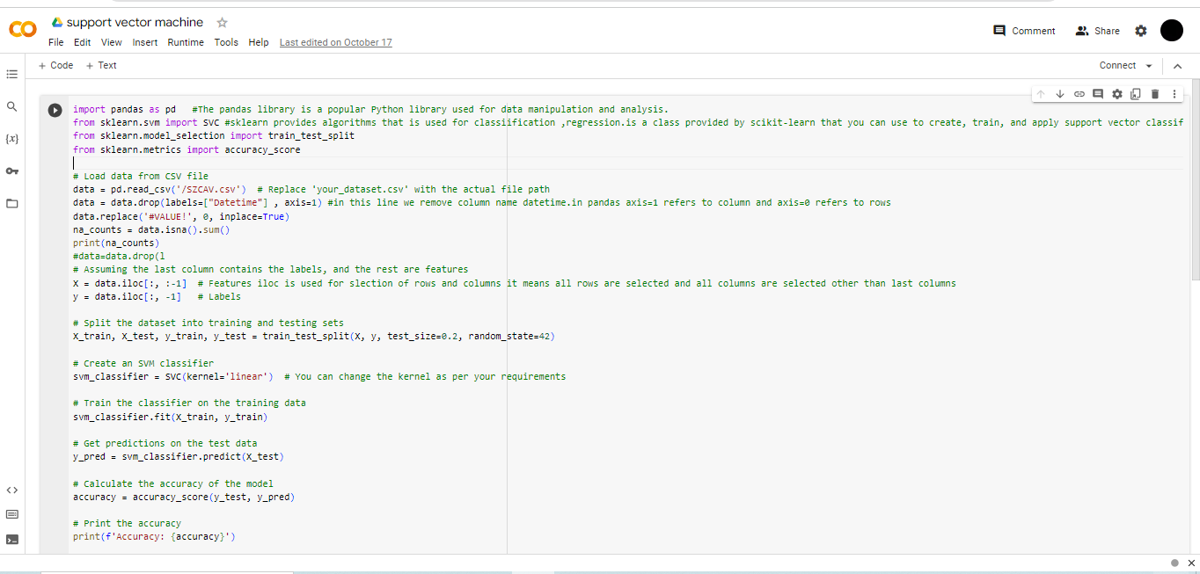

Figure 3.18.1Algorithmic viewpoint for SVM

DEVELOPMENT AND TOOLS

Introduction

This section shortly describes the development plans and technology adopted to achieve these goals by executing our plan. The highest motivation of planning is to get work done to meet academic deadlines and to keep our work aligned. Moreover, these are several tools and ways to perform a task. This section best describes choices made by our own team

Development Plan
This project is developed by two team members.
- Faaiz Umar
- Wasil Nadeem
All the project is developed with teamwork between members. Tasks were divided equally according to the specially of each member. Like this both team members have worked together on multiple modules of this project.

Task | Faaiz | Wasil
Application Review | ✓
Problem Statement |  | ✓
Scope Documentation |  | ✓
Frontend Development | ✓ | ✓
Backend Development | ✓ | ✓
Database System Design | ✓ | ✓
Mid Presentation/ SRS/ Demo video Preparation | ✓ | ✓
Final Presentation / Report Preparation | ✓ | ✓

Table 4.2 Development Plan

Task | May/June | July/Aug | Sep/Oct | Nov/Dec
Application Review
Problem Statement
Scope Documentation
Frontend Development
Backend Development
Database System Design
Mid Presentation/ SRS/ Demo video Preparation
Implementation of 50% Functionalities
Implementation of 100% Functionalities
Final Presentation / Report Preparation

Table 4.3 Giant chart

Development Tools
- Visual Studio Code
- Python
- Django

Conclusion and Future Work/Extensions
In conclusion, the implementation of data-driven fault detection in an air handling unit (AHU) using Neural Networks (NN), Support Vector Machines (SVM), and k-Nearest Neighbors (KNN) has proven to be a promising approach. The utilization of these machine learning algorithms has demonstrated the potential for accurate and efficient detection of faults in AHUs, contributing to enhanced system reliability and operational efficiency.
The developed user interface plays a crucial role in providing a user-friendly and intuitive platform for visualizing the detected faults and system performance. This facilitates quick decision-making and allows stakeholders to take timely actions in response to identified issues.

QUALITY ASSURANCE

In the system development paradigm, quality has equal importance as functional requirements. This section was built to propose some highly recommended quality goals necessary for our system to be chosen by clients. There are some predefined sets of rules that uniformly determine the quality of our system. We will try to cover all in the section below

Introduction

Quality assurance in the implementation of data-driven fault detection for air handling units is a cornerstone of our project, ensuring the reliability and efficacy of advanced machine learning algorithms, including deep neural networks, SVM, and KNN. Our meticulous testing protocols encompass a diverse range of operational scenarios, validating the system's ability to proactively identify and diagnose faults in real-time data streams. This commitment extends to the user interface, where usability testing guarantees an intuitive and informative experience for stakeholders. By instilling confidence in the accuracy and trustworthiness of the fault detection system, our comprehensive approach to quality assurance not only facilitates timely and effective maintenance interventions but also underscores our broader goal of optimizing the efficiency, sustainability, and overall performance of air handling units through cutting-edge data-driven methodologies.

Moreover, the quality assurance process extends to the user interface, emphasizing the importance of a seamless and intuitive experience for stakeholders. Usability testing ensures that the web interface for data visualization not only effectively communicates insights but also empowers users with actionable information for timely decision-making. The project's dedication to quality assurance instills confidence in the reliability of the fault detection system, providing assurance to HVAC system operators that proactive maintenance interventions are based on accurate and trustworthy data. This holistic approach to quality assurance is integral to achieving the project's overarching objective of optimizing the efficiency, sustainability, and overall performance of air handling units through state-of-the-art data-driven methodologies.

Traceability Matrix

 | Tc-1 | Tc-2 | Tc-3 | Tc-4 | Tc-5 | Tc-6 | Tc-7 | Tc-8 | # Test Cases for  respective  Requirements
Req_ID
Req_1 | x |  |  |  |  |  |  |  | 1
Req_2 | x | x |  |  |  |  |  |  | 2
Req_3 |  |  | X |  | x |  |  |  | 2
Req_4 |  |  |  |  | x |  |  |  | 1
Req_5 |  |  |  |  |  | x

 |  |  |  |  |  |  |  |  | 1
Req_6 |  |  |  |  |  |  | x |  | 1
Req_7 |  |  |  |  |  |  |  | x | 1

Table 5.1: Traceability Matrix

Test Plan

Test ID | TC-1
Test Name | Accuracy Test by SVM
Date of test | 11/15/23
Name of application | Data Driven Fault Detection in AHU
Description | Train the classifier on the training data
Input | Get predictions on the test data
Expected Output | Model Accuracy
Actual Output | Model Accuracy
Test Role | Team Member
Test Verified by | Supervisor

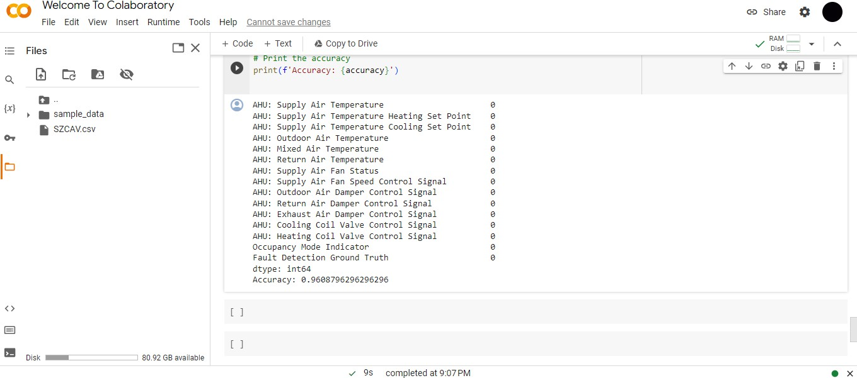
Figure 4.1 Ai svm test case

Test ID | TC-2
Test Name | Accuracy Test by KNN
Date of test | 11/15/23
Name of application | Data Driven Fault Detection in AHU
Description | Train the classifier on the training data
Input | Get predictions on the test data
Expected Output | Model Accuracy
Actual Output | Model Accuracy
Test Role | Team Member
Test Verified by | Supervisor

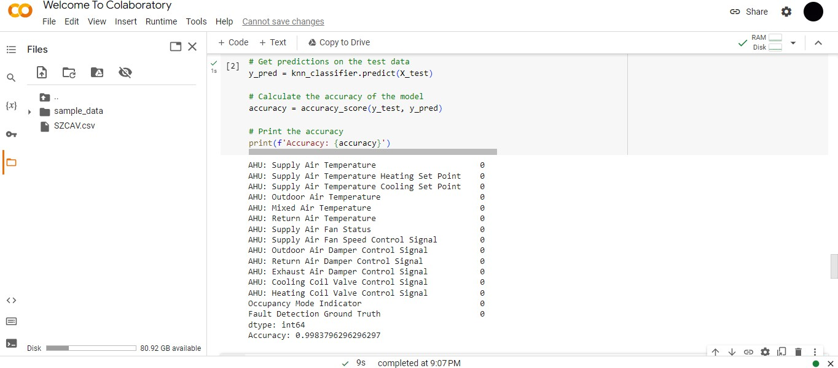
Figure 5.2 Ai knn test case

Test ID | TC-3
Test Name | Accuracy Test by KNN
Date of test | 11/15/23
Name of application | Data Driven Fault Detection in AHU
Description | Train the classifier on the training data
Input | Get predictions on the test data
Expected Output | Model Accuracy
Actual Output | Model Accuracy
Test Role | Team Member
Test Verified by | Supervisor

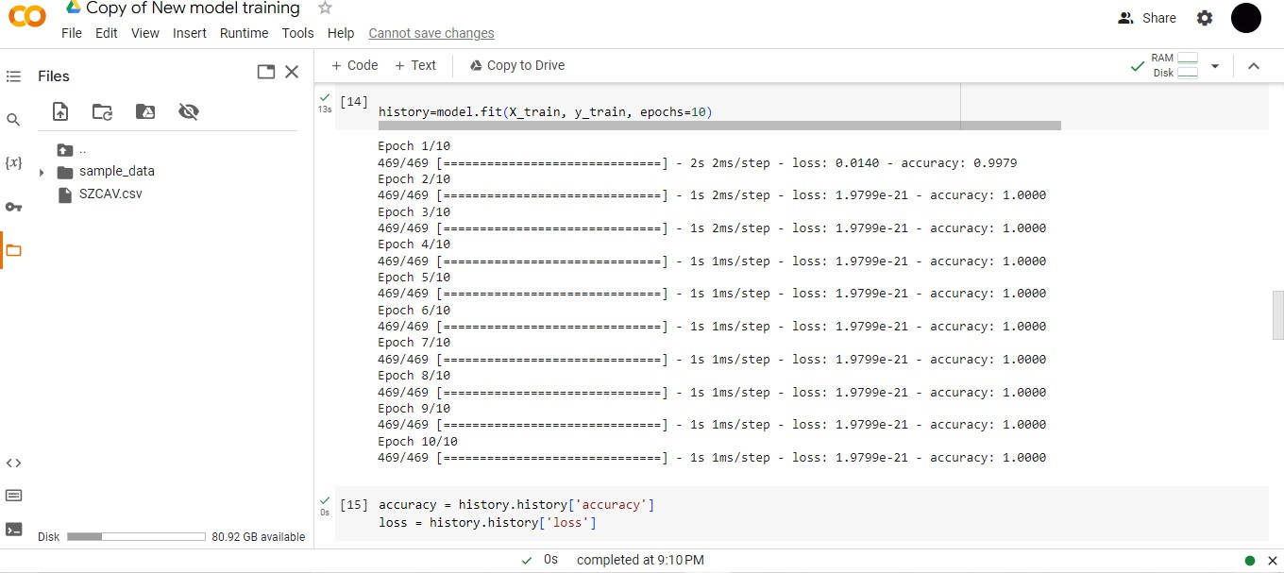
Figure 5.3 Ai NN test case

USER MANUAL

Introduction
Welcome to the user manual for our innovative project, "Data-Driven Fault Detection in Air Handling Unit." This system employs state-of-the-art technologies, including Deep Neural Networks, Support Vector Machines (SVM), and K-Nearest Neighbors (KNN), to enhance the detection of faults in air handling units. This manual serves as your guide to navigate our web interface, where you can visualize crucial data in the form of insightful graphs. Whether you are monitoring system performance, analyzing fault trends, or exploring predictive insights, this user-friendly interface provides a comprehensive and interactive experience. Follow the instructions within this manual to harness the power of advanced algorithms and seamlessly interpret visualized data for effective decision-making in air handling unit maintenance and optimization.

Hardware/Software Requirements for the System
    - Software Requirements:
- Operating System: Windows
- Make sure the chosen system must have that library and frameworks
    - Python Environment
- Python 3.6 or higher
- Required packages and libraries (installable using pip):
- NumPy
- Tensor-flow
- Scikit-learn
- Keras
- MATLAB
- Any other libraries specific to your implementation
    - Development IDE
Anaconda or any Python-compatible IDE (e.g., Jupiter Notebook, Visual Studio Code, Google Collab)
    - Database
- SQLite or any other relational database for storing and retrieving training data.
    - Neural Network Framework
- TensorFlow or pyTorch (depending on your preference and compatibility with your models)
    - Support Vector Machine Library
- Scikit-learn includes SVM implementation.
    - K Nearest Neighbor Library
- Scikit-learn includes KNN implementation
6.2.8. User Interface (UI)
- Any GUI framework compatible with your chosen programming language
- Ensure that the required UI components are properly installed

Installation guide for Application
Our website required mandatory installation of Metamask extension on your computer or laptop. The installation steps of Metamask extension are as follows,
1: Python Environment Setup
- Install Python (if not installed): Python Installation Guide.
- Set up a virtual environment (recommended): python -m venv venv.
- Activate the Virtual Environment
- On Windows: venv\Scripts\activate
- On Linux/Mac: source venv/bin/activate
2: Install Required Libraries
- Install necessary libraries using pip command
- pip install NumPy pandas scikit-learn TensorFlow

Operating Manual

6.4.1 First screen
Figure 6.4.1.1 first screen

Figure 6.4.1.2 invalid login

6.4.2 Second Screen

Figure 6.4.2.1 second screen with fault detected

Figure 6.4.2.2 second screen with no fault detected

7. CONCLUSIONS
This chapter concludes our achievements of this project and how well we've been able to complete it.

  - Conclusion
In conclusion, the undertaken project focused on implementing advanced machine learning techniques for data-driven fault detection in air handling units (AHUs). The combination of Neural Network, Support Vector Machine (SVM), and k-Nearest Neighbors (k-NN) demonstrated promising results in identifying and classifying faults within the system.
The utilization of Neural Network allowed for the creation of a robust model that could capture complex patterns and relationships within the data, enabling accurate fault detection. SVM, with its ability to handle both linear and non-linear relationships, provided an additional layer of sophistication, enhancing the model's overall performance. The k- NN algorithm, relying on proximity-based classification, offered a valuable perspective on fault detection by considering the similarity of data points.

The integration of these machine learning algorithms into a user interface for visualization proved to be crucial for practical implementation. The user interface not only facilitated the interaction with the model but also provided a comprehensive and user-friendly platform for users to interpret and analyze the results. Visual representations of fault predictions and system health metrics aided in quick decision-making and troubleshooting.

Throughout the project, extensive testing and validation were conducted to ensure the reliability and generalizability of the fault detection models. The results demonstrated a high level of accuracy and efficiency in identifying various faults, ranging from mechanical issues to sensor anomalies. The project's success in achieving reliable fault detection in AHUs holds significant implications for the maintenance and performance optimization of HVAC systems.
As the field of machine learning continues to evolve, the developed fault detection system can be further enhanced and adapted to accommodate new data sources and improve overall predictive accuracy. Moreover, the user interface can be expanded to include additional features, such as real-time monitoring, trend analysis, and automated reporting.

In conclusion, this project represents a significant contribution to the domain of HVAC systems maintenance by leveraging cutting-edge machine learning techniques. The successful integration of Neural Network, SVM, and k-NN, coupled with an intuitive user interface, provides a robust foundation for future developments in the realm of data-driven fault detection and predictive maintenance for air handling units.

REFERENCES
- How to build an NFT Marketplace from Scratch - Solidity and IPFS | Road to Web3, URL:
”https://www.youtube.com/watch?v=y6JfVdcJh1k&ab_channel=Alchemy”

- Code an NFT Marketplace like OpenSea Step-by-Step [ERC-721, Solidity], URL:
“https://www.youtube.com/watch?v=2bjVWclBD_s&ab_channel=DappUniversity”
- Build OpenSea Blockchain Web 3.0 App with Next.js | Sanity.io | thirdweb, URL:
“https://www.youtube.com/watch?v=x3eRXeMB-4k&ab_channel=CleverProgrammer”

- Build your own NFT marketplace like OpenSea clone with solidity,openzeppelin and polygon (SUBSCRIBE), URL:
“https://www.youtube.com/watch?v=7Q5E6RvLlUw&t=19673s&ab_channel=BraintempleTutorialTV”

- How to Build a Full Stack NFT Marketplace on Ethereum with Polygon and Next.js - [2021 Tutorial], URL: “https://www.youtube.com/watch?v=GKJBEEXUha0&ab_channel=NaderDabit”

